**S.NO. DAIRY PRODUCTS FULL HALF**

**1. Milk 50/- 25/-**

**2. Curd 80/- 40/-**

**3. Paneer 440/- 220/-**

**4. Khoya 400/- 200/-**

**5. Desi Ghee 600/- 300/-**

**6. Mithi Lassi 50/- 25/-**

**7. Mango Lassi 100/- 50/-**

**8. Strawberry Lassi 100/- 50/-**

**9. Namkeen Lassi 40/- 20/-**

**10. Makhan 450/- 225/-**

Address: Kirat Sweets, Near Chadha Transport, Safabadi Gate, Sirhindi Bazar Rd, Patiala, Punjan-147001

Contact: 8054811888, 9780272699

E-mail: kiratsweetsanddairy@gmail.com

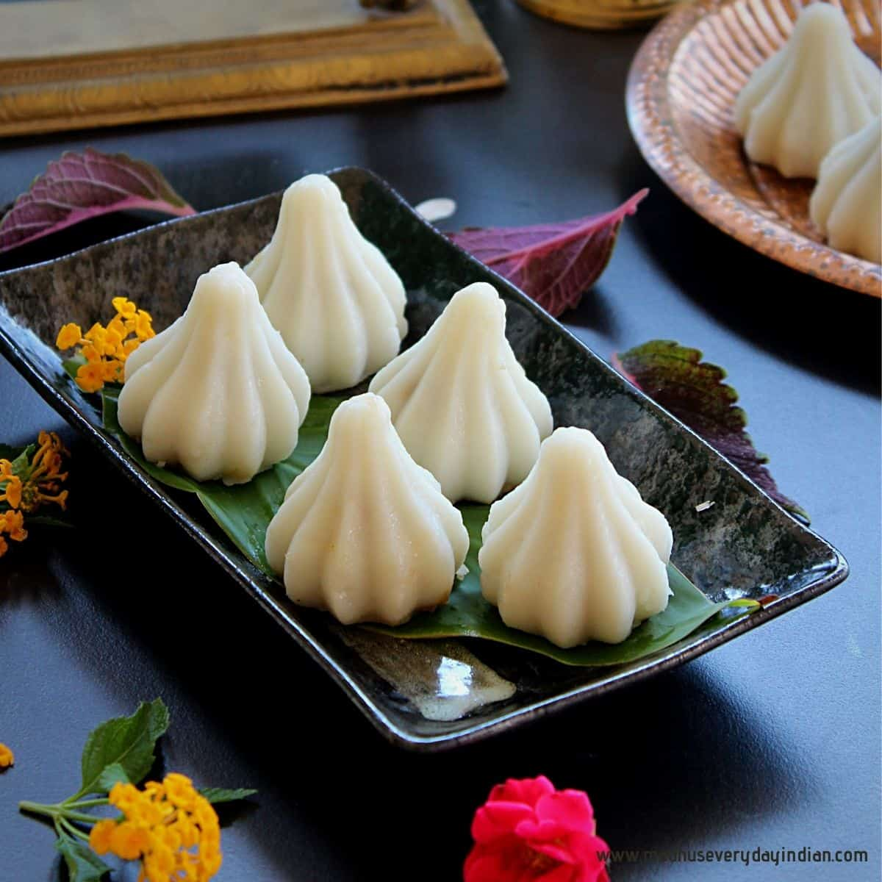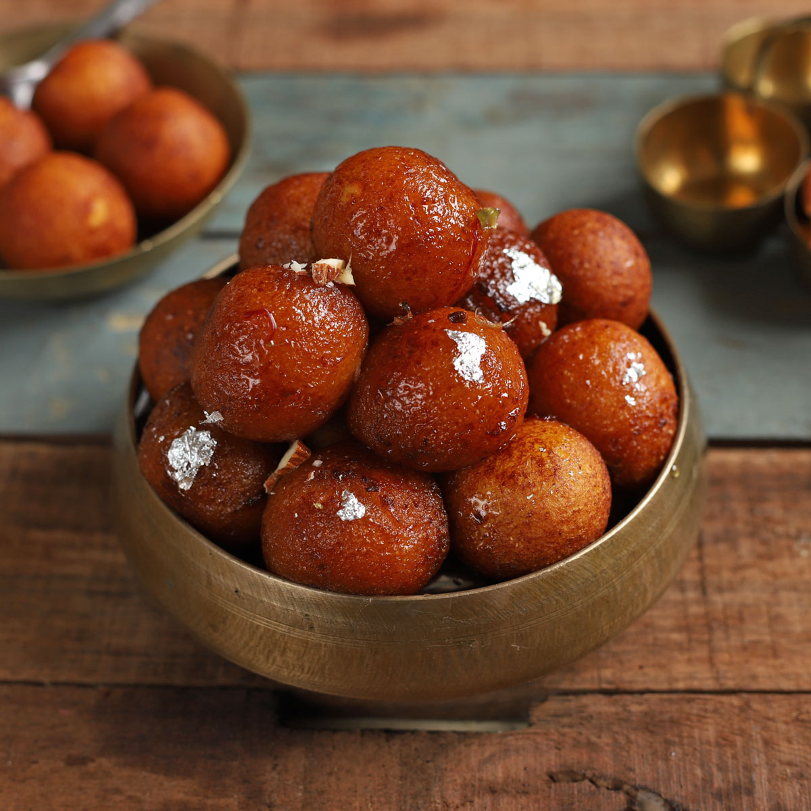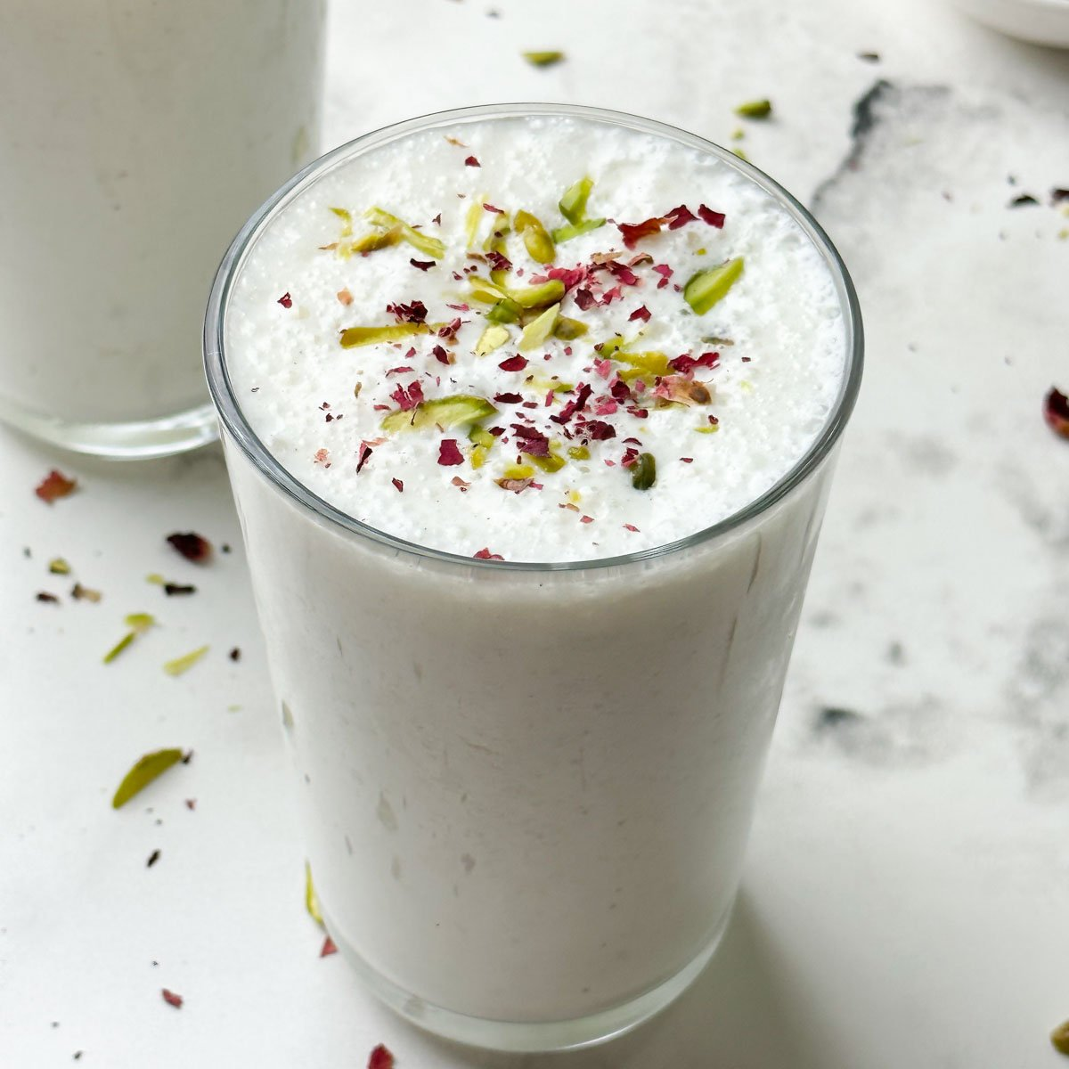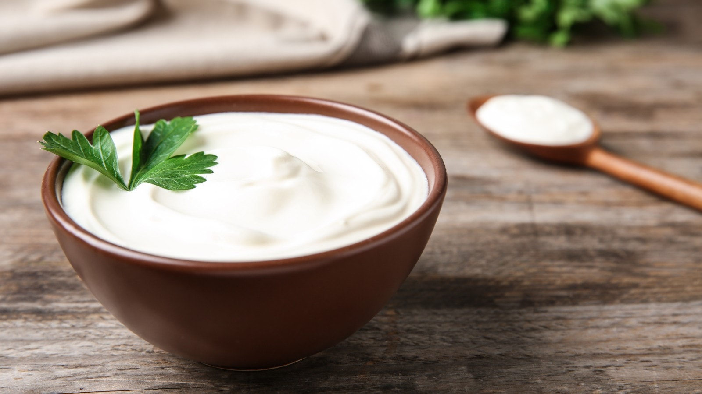

FOOD MENU



**Kirat Sweets And Dairy**